

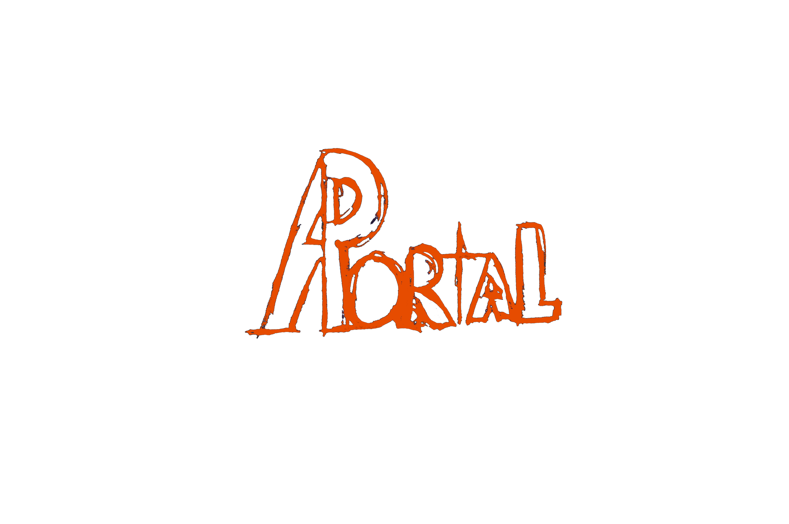

Software Development(Semester 2 Project)

Group

Chris : X00128141

Igors : X00128490

Ryan : X00131076

Aran : X118718

User Requirements – 3 wks

Content

Visuals

Colours

Background-colour : #404040

Primary-text-colour : #e64d00

Secondary-text-colour : #df2020

User Requirements - Upload Date (12/02/17)

# 

# Progress - Status & Workload

Ryan & Chris

Survey/Interview : Finished.

Ryan,Chris

Survey,Interview Reviews : Finished.

Igors

Narative,&Requirements: Finished.

Ryan

Use Case Diagram : Finished.

Aron,Ryan

Use Case Descriptions : Finished.

Igor's,Ryan

Class Diagram : Finished.

## 

## 

## Survey

The survey is based on knowledge of our crowd on the subject of Anime & Manga & just to get a second pair of eyes on the colour scheme and layout we had chosen for our webpage.

Results

Q1

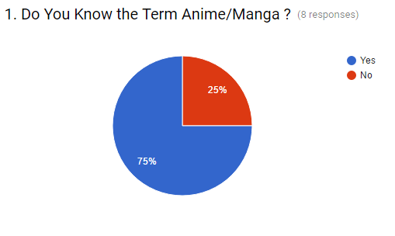

As you can see a good majority said they understood these terms so this was a possible indicator for us that those are a possible user if they're not already interested in these areas at some point become one.

Q2

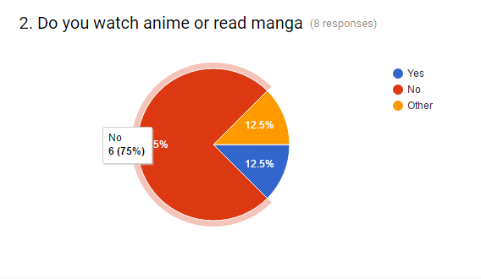

This has surprised us compare to the fact that so many people new these terms these results might not have been what we were hoping for but it just lets us know that if we do want that big user base for our website we might need to try keep it as user friendly as possible and pleasing to the eye’s.

Q3



On our part Q3 was a bit vague so bad on our side but from those who had understood the question, we got answer’s so as to focus on quality content overall so what we took from that is to yes gather a lot of content as all we will be is a navigation service but it doesn’t mean that we don’t put Emphases on Manga/Anime that is really popular and well known for their quality.

Q4



This was the question that we got some very helpful feedback on the first was the secondary colour we used it was very dark which made text very hard to read so that has been noted, others were just more a general preference to brighten the page up but the four us agree that the pages colour scheme of some dark colours and some light is that which best suits our content on the page.

## Interview

The following is a transcript of a few interviews conducted to get a feel of what a typical user would want in a site like ours.

1. Are you familiar with the terms Anime or Manga?

Yes both.

Yes

1. Do you watch Anime or read Manga?

Yes I do both.

Yes

1. If you were to search for a website that enables you to search for an Anime or Manga, then sends you to other websites so you can watch or read that particular series, What sort of features or items would you expect to see on a website like that?

I would expect to see things that showed us upcoming events from those other websites, for example RWBY (The name of an Anime that has become popular), I would like to know when the next airing of it would be or if a new season is coming out, that type of thing. Something like a release schedule.

I would expect to see new links or new updates that I am trying to find, say if there is a dubbed version of the anime I would try and look for that rather than the subbed. If I was going to read a Manga I would rather have one that is mobile phone compatible so that I only have to swipe to turn the page rather than having to tap on next or something.

1. After showing you an image of our conceptual home page, is there anything you would suggest we could change or alter to make it better?

It actually looks pretty straight forward, it’s clean. I would suggest that if you are producing something like this from scratch maybe you also have a dark version of the website as well. I would class this version you have here as a light version which most websites are based upon a white background. Some people have problems with things on white backgrounds and others require darker backgrounds to be able to see the item properly because white is too much for them.

(Prior to answering the next question I answer some of their questions about the page.)

I would suggest having the buttons on the nav bar as drop down menus, for instance if you were looking for an Anime and you want to look for a gener you would click on it and the type of Anime you are looking for would pop up. Another suggestion would be maybe not to have the same colour for every single bar (nav bar) like the ones on the left and right of the page, maybe have those different colours and have the others as they are.

1. If the website were to sell merchandise or products, what kind of items would you expect to see?

A varying variety with various prices in other words, things from small trinket idea items that may only cost pocket money (prices) up to maybe certain items that have prices that a child could not afford, that sort of variation. Other items I would like to see in something like that would be books (Manga), the usual t-shirts, posters, figurines and box-sets that type of thing. People are after merchandise that is slightly different say (for instance) the Death Note that is a slightly different kind of item it’s a book that comes from Anime and a lot of people want that kind of thing. Even cups or mugs with images of the Anime people would do them as collections. I would suggest staying away from selling items from the darker side of Anime but I realise that it has to be appropriate due to it being a collage project.

I would say t-shirts, bags, badges, figures; the usual kind of things you would see on a merchandise website.

1. If the website were to have a chat feature / section would you think that it would benefit the website or take away from it?

I have seen sites, in the past sites have gone offline because the chats are only postable not readable, I have also seen sites go offline that are well established that added chat as a perk for long established members or people of certain ranks on their website. If it is open direct chat in other words a live chat that can make or break a site. (At this point I inform them that our thoughts were more along the lines of a forum.) If it’s like a forum, text chatting in other words that is always useful on any site. It could probably promote things like people's favourite Anime or Manga and have different sections related to different topics for instance FAQ or staff help I think it may help something of this ilk. I would steer away from the live chat in my opinion.

It could benefit because the people who have similar interests in different Anime or Manga could talk together about the Anime but there are also the disadvantages of it for instance people could give hate to each other or be mean to each other.

## 

## Conclusion of interview

## Based on what we can gather from the interview one of the things that a typical user would look for would be some form of schedule of when a new episode would be released or if there is some form of event happening on the external websites. Another thing would be having the option for a user to choose between dubbed versions of the Anime and Manga or subbed versions of the Anime or Manga.

## In relation to the shop aspect the general feeling is that there should be a variety of items for sale as well as the typical items each of which varies in price anywhere from pocket money prices to expensive items.

In relation to a chat or forum feature or section it appears to us that a live chat is a very risky idea on a website. However the concept of a forum would be of benefit to the site to bring the community together. In both scenarios the text would have to be moderated so that the amount of negativity is as low as possible.

## 

## Narrative

Main page

When the user is on the main page of the website, he is able to go to a product page , an anime page, manga page and a forum page. The user is also able to see the top viewed anime and have an ability to sign in or login. the user can click on the cart to see what’s inside of it. At the bottom of the website user can see About us link and Support link.

Product page

When the user accesses a product page at the top users will see the navigation bar which includes links to cart, sign in & sign up, Products, Anime,Forum & Manga user will also see just below this a search bar, categories will be displayed on the left hand side for users to pick from on the right side users will see the products in order of popularity and at the bottom of the page will be the footer which will contain links to both about us and support pages.

User can click on the product and see more details about it.

Users that are logged in are allowed to click buy ( put into cart )

Anime page

When the user enters an manga page at the top users will see the navigation bar which includes links to cart, sign in & sign up, Products, Anime,Forum & Manga user will also see just below this a search bar, categories will be displayed on the left hand side for users to pick from, right side the Anime will be displayed in order of popularity, at the bottom of the page the user will see the footer which will contain links to the about us and support us pages.

The user can search the Anime via the search bar or categories. when Anime is clicked user sees more information about it and is presented with links where he is allowed to watch Anime.

Manga

When the user enters an manga page at the top users will see the navigation bar which includes links to cart, sign in & sign up, Anime, Forum,Manga & Products user will also see just below this a search bar, categories will be displayed on the left hand side for users to pick from, on the right side the Manga will be displayed in order of popularity, at the bottom of the page the user will see the footer which will contain links to the about us and support us pages.

The user can search the Manga via the search bar or categories. when Manga is clicked user sees more information about it and is presented with links where he is allowed to read Manga.

Forum

On the Forums page at the top users will see the navigation bar which includes links to cart, sign in & sign up, Anime, Manga,Forum,Products user will also see just below a search bar & to the far left hand side there will be topics Links along with a plus symbol to create topics and on the right side there will be various posts by default general below this section there will be the footer along with is links about us and support.

The user has to be logged in in order to access topics and create new topics.

Inside the topics the user can read posts and post posts himself.

Sign In & Sign up page

this page will display the top navigation bar which contains a link to cart, sign in & sign up, products, anime & manga just below this there will be two forms centered on the page first will be for Sign In and the Second will be for SignUp below these will be the footer which contains links to the about us and support pages .

Functions of this page as you would expect from the name are sign up or sign in other than that from here you can navigate to other pages.

## Requirements

1. User must be signed in as member before they can buy products,view cart or create topics.
2. User must be signed in as admin in order to add new Products/Media, Update them or delete them etc..
3. User must have first created account before signing in.

## Use Case Diagram

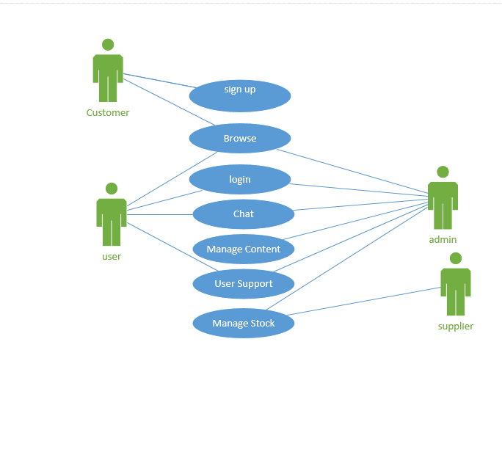

## Use Case Description’s

SignUp

|  |  |
| --- | --- |
| Use Case: | Sign Up |
| Actor(s): | Customer |
| Goal: | To Allow new customer to make a account on our website. |
| Overview: | Customers will be required to provided to give first and last name, email address and they will choose a username to personally identify them, they will optionally be allowed to entered address for delivery purposes of merchandise and there credit card details required for purchases. |
| Pre- Condition: | They Must first provide first and last name, email address & username. |
| Post- Condition: | They must verify account creation through email. |
| Successful Scenario: | The customer enters the required details, they find a unique user name and verification link is then sent to their email which they then access and use to verify that they are the person setting up the account with this specific email & are then able to use the websites other features. |
| Alternative Scenario(s): | The customer enters required details but the email has already been used for other account.  They enter the required details but user name has already been used so they must pick another user name and retry. |

Login

|  |  |
| --- | --- |
| Use Case: | Login |
| Actor(s): | User, Admin |
| Goal: | To access User's account. |
| Overview: | The user will enter there previously used details used to Sign Up such as email/username & password into a form to which will then be checked for valid account with the same details if so they will be Signed in and allowed to use the websites extra features such as chat and purchasing items. |
| Pre- Condition: | They must first have an account created so as to login.  They must enter all details correctly. |
| Post- Condition: | N/A |
| Successful Scenario: | The user enters their details correctly, the website checks details entered for validation and they are then taken to the homepage and are able to use the websites extra features. |
| Alternative Scenario(s): | The System checks details entered against what the system has and find that details match no existing account so user is returned to sign in. |

Browse

|  |  |
| --- | --- |
| Use Case: | Browse |
| Actor(s): | Public,Admin,User |
| Goal: | To allow people to access basic features on the website. |
| Overview: | The public will all have access to the website but to have access to our extra features such as chat & buying items they must create an account. |
| Pre- Condition: | N/A |
| Post- Condition: |  |
| Successful Scenario: | The Person types URL clicks websites link and then has access to the basic functionality of the website. |
| Alternative Scenario(s): | The Person attempts to access the page but it does not load due to either the fact of Internet access on there end or server problem on ours in that case they will fail to browse the web page. |

Chat

|  |  |
| --- | --- |
| Use Case: | Chat |
| Actor(s): | User,Admin |
| Goal: | To Allow Admin/User to access the chat to perform their task that requires them to use it. |
| Overview: | The User can access the chat after logging in and from there they can create new chats(Forum/Blog style) where from there they can either make it public for anyone to access or private to allow only people they know to access and have a discussion about manga, anime or anything they wish to discuss.  The Admin can do anything the user can but they can also delete conversations for reasons they deem appropriate. |
| Pre- Condition: | They Must first be Signed in before they can use chat.  Before creating a chat they must give it a discussion name and privacy policy (public/private) |
| Post- Condition: |  |
| Successful Scenario: | The User /Admin signs in and is able to access chat through the navigation bar on the home page and either create/join a chat and discuss a particular topic or just read discussions. |
| Alternative Scenario(s): | The User/Admin tries to login and is unable so is then unable to access chat.  The User/Admin gets into chat but is unable find a particular type of discussion so they must either create a new one for it or contact customer support if it has been deleted for an explanation. |

Manage Content

|  |  |
| --- | --- |
| Use Case: | Manage Content |
| Actor(s): | Admin |
| Goal: | To Allow The Admin to access features that ordinary users cannot. |
| Overview: | The Admin will be allowed to from here Add/Update/Delete Content on the Website. |
| Pre- Condition: | They Must first be signed into valid Admin account. |
| Post- Condition: |  |
| Successful Scenario: | The Admin enters their details the system finds a valid Admin account and they are then able to perform the tasks that they logged in to perform. |
| Alternative Scenario(s): | The Admin attempts to sign in but there details are not valid so they are then denied access.  The Admin Signs in but They are not able to access these features for certain reasons such as the system is being updated. |

User Support

|  |  |
| --- | --- |
| Use Case: | User Support |
| Actor(s): | User,Admin |
| Goal: | To provide help for the end user. |
| Overview: | The Users will be able to submit queries based on those that are provided enter some text to explain their issue and it will then be sent to the web server for the Admins of the website to review.  The Admin will be able to access the queries,read and delete them once they have been responded to through the user's email. |
| Pre- Condition: | The User must first be signed in before they can submit queries.  The Admin must also be signed in so as to read and delete queries. |
| Post- Condition: | The Admin after responding to user’s query must then delete it the query to save space. |
| Successful Scenario: | The User after Signing is then able to create and send their queries for the Admin to answer and remove. |
| Alternative Scenario(s): | The Admin/User is unable to access their account so they are unable to access the query part of the website.  The Admin attempts to remove query down to a issue with the server. |

Manage Stock

|  |  |
| --- | --- |
| Use Case: | ManageStock |
| Actor(s): | Admin,Supplier |
| Goal: | To allow access to new stock. |
| Overview: | The Admin when stock is low will be able to request new stock from the supplier through the system & they will be also able to request new types of stock and add it to the system.  The Supplier will deal with handling the order given by the Admin & delivering it. |
| Pre- Condition: | The Admin must first be signed in.  The Admin must also specify whether it is new stock they are looking for or stock they are just wanting to get more. |
| Post- Condition: | The Admin must mark of stock request once it has been delivered so that it is not seen as an unfulfilled request. |
| Successful Scenario: | The Admin Signs in selects the manage stock feature chooses whether or not it's new or current stock they want and then the amount they are requesting and once the order has been sent Supplier will gather the order and deliver the items. |
| Alternative Scenario(s): | The Admin is unable to sign in and is then unable to perform the task.  The Admin has signed in but the request they have sent is not delivered to the Supplier due to network connection.  The Order is Delivered but the Supplier is unable to deliver the stock because it is not availabDiagram |

Class diagram

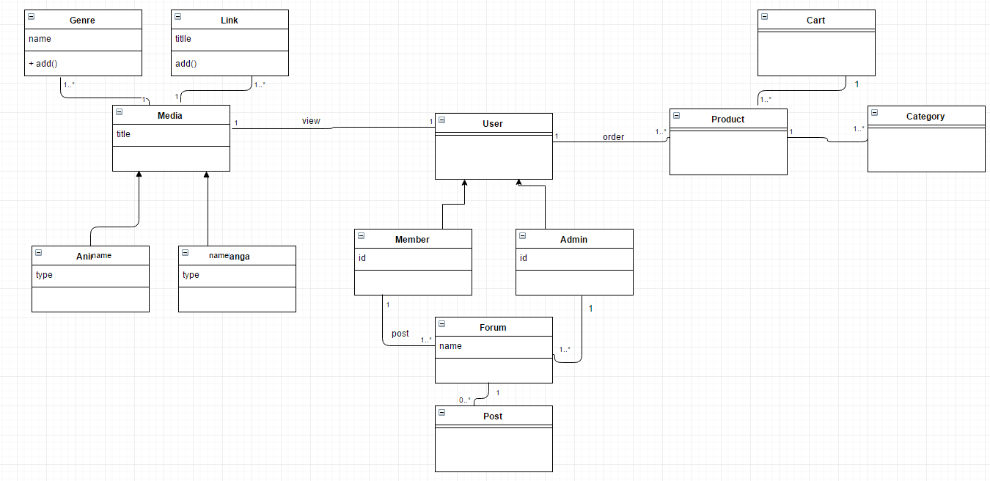

Broad Class Diagram

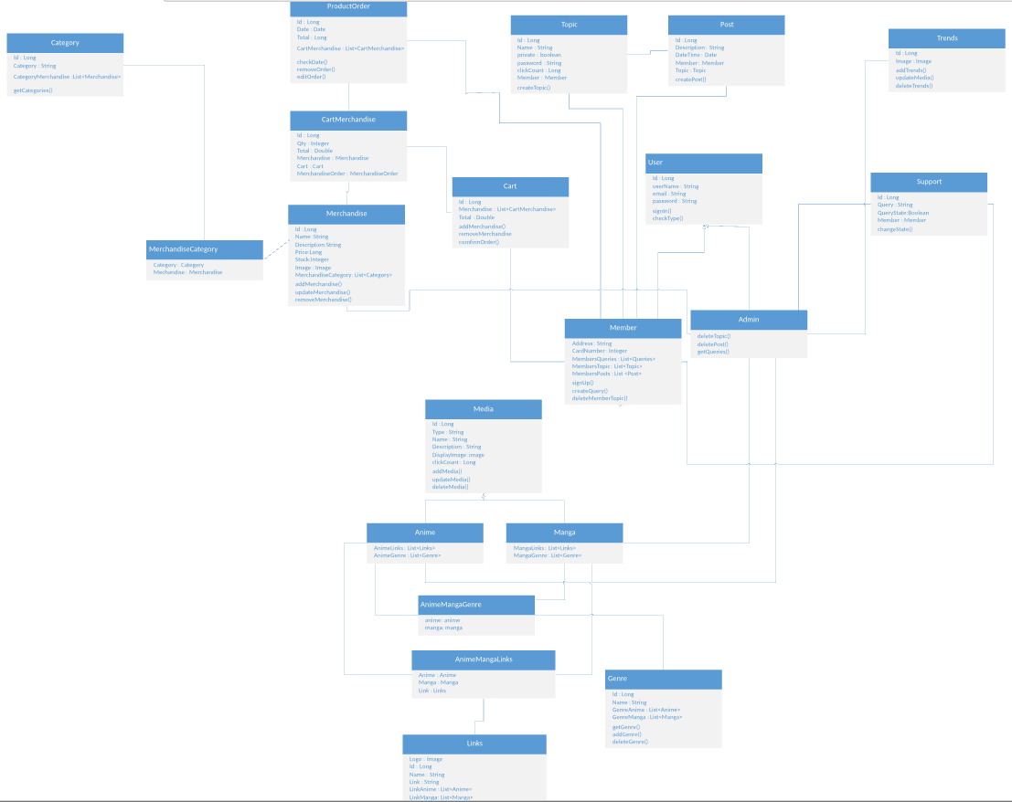

SECTION 2

# Page Design

Page :Home page

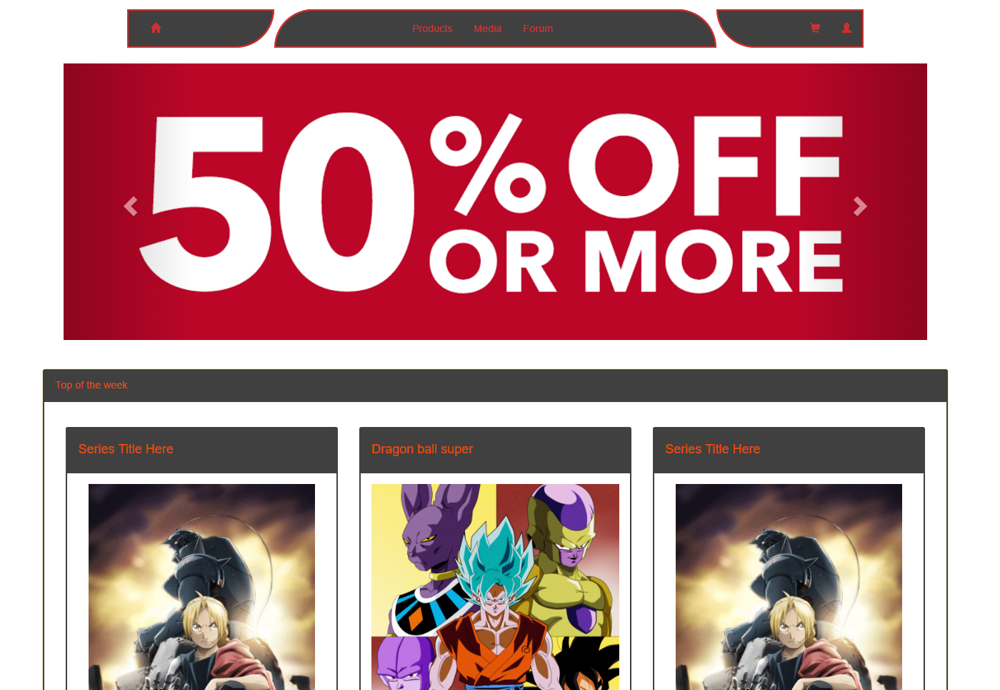

On this page any type of user can view our special deals and Top of the week. The user will also be able to click on any anime from top of the week to see more information about them. Clicking on any of the deals will bring the user to the product page.

Page : Sign Up Sign In

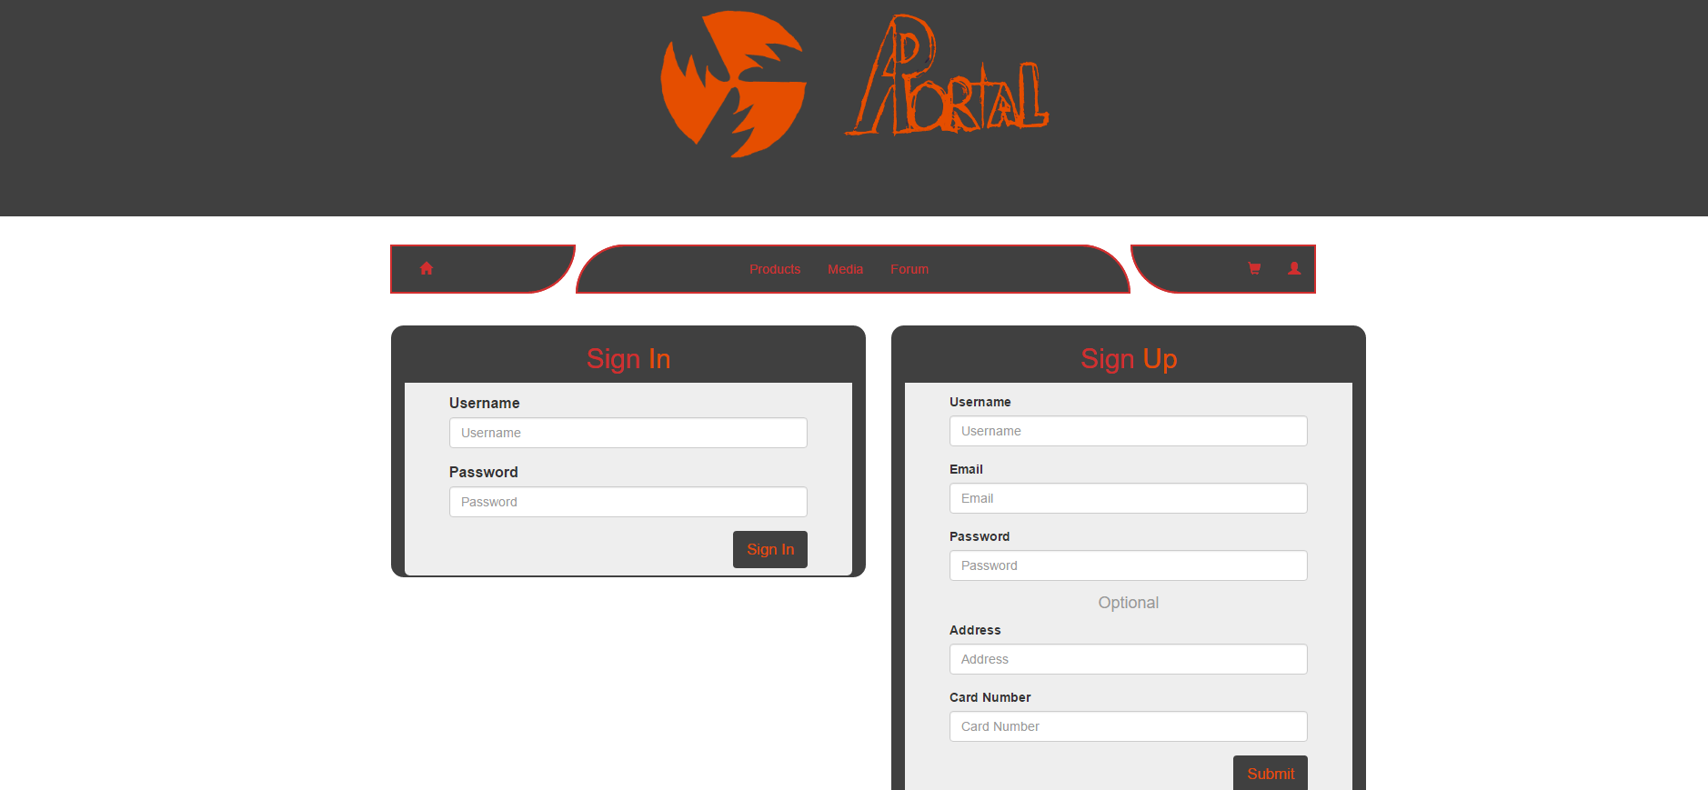

From this page the user will be able to sign up & become a member and through this page he will also be able to sign into his/her account.

Note : Admins will not be able to SignUp they will be manually inserted into the tables.

Page : Support

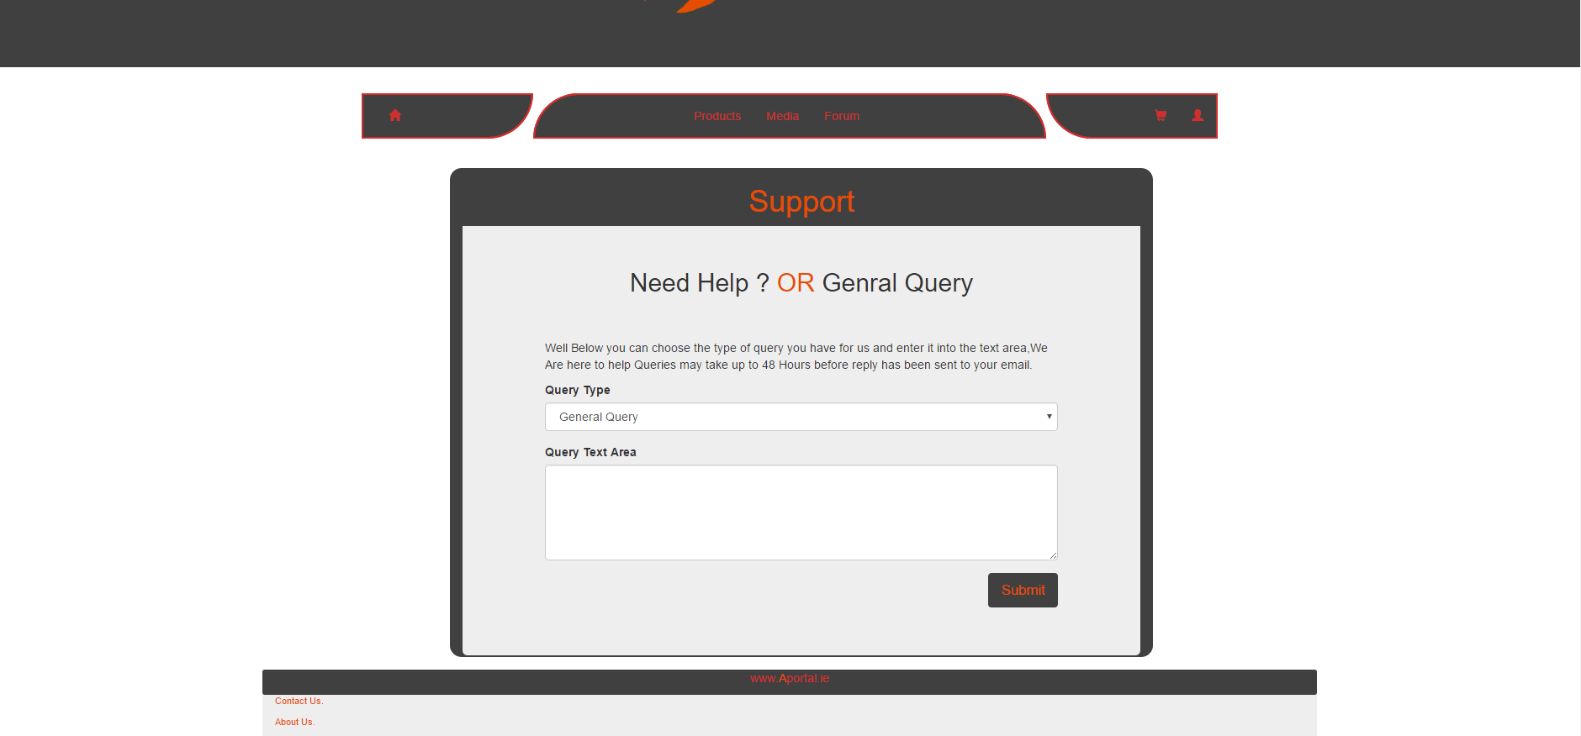

From the Support page the users if signed in only will be able to send queries to the website on based on certain type of query they it is.

Note : Users must first be signed in.

Page : adminHome

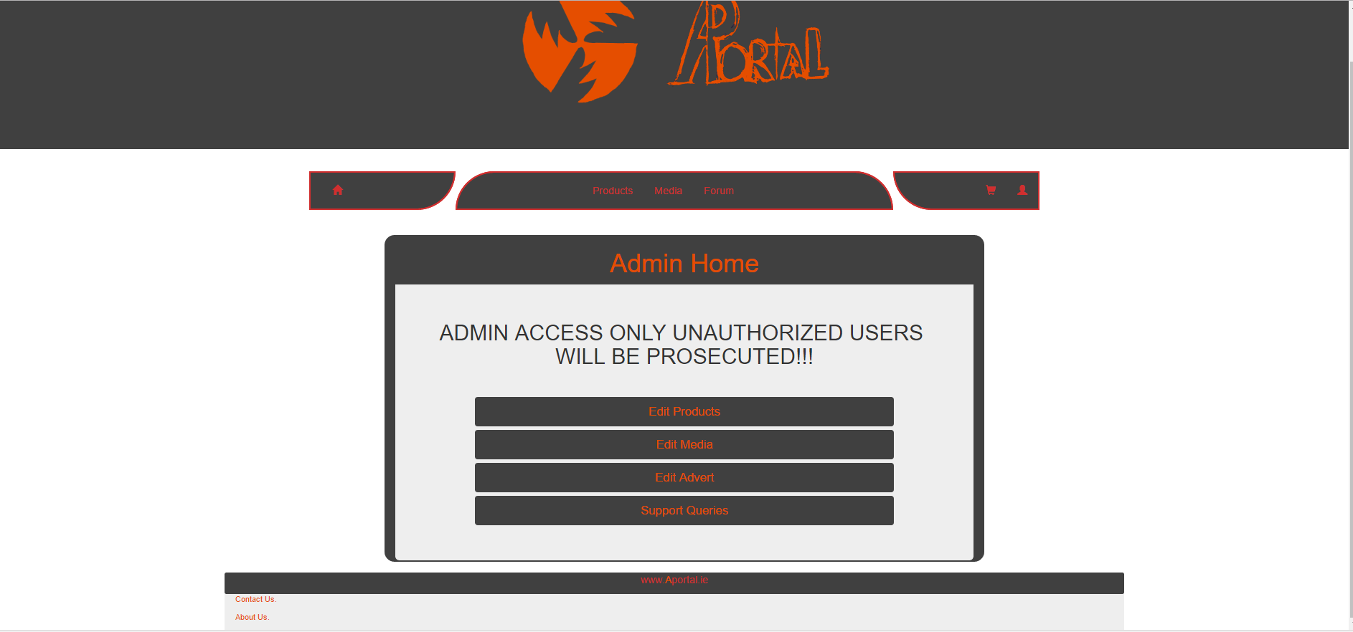

This will be a page to which admins will be able to navigate to their required html pages to make changes to the databases tables.

Note : Only Admins will be able to access this page.

Page : adminSupport

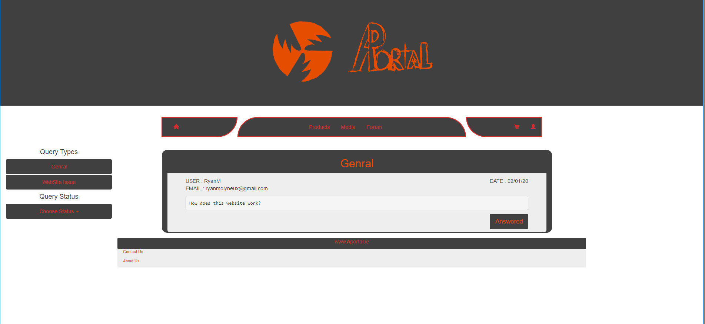

From this page admins will be able to view queries sent by members to the database they use the left navigation link to view certain types of queries and once they have answered the query through email they will be able to click the answered button on the page to change the queries status in the database.

Note : Only admins will be able to access this page , also the Query status part of the navigation bar will be used for the admin to switch between unanswered and answered queries.

## 

## Add Product

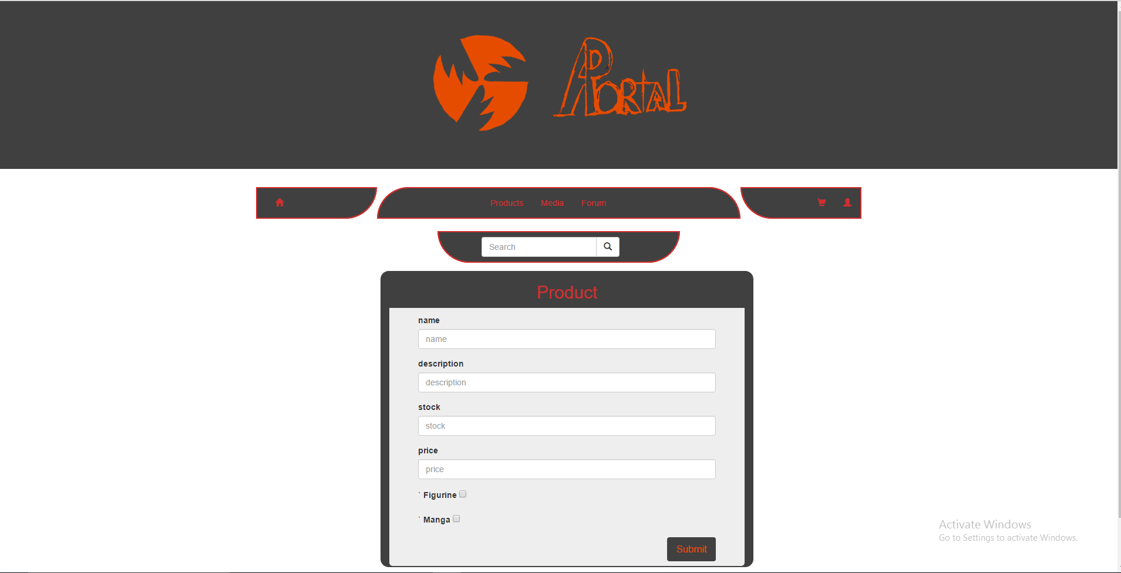

the admin edit media & product pages will be similar in design and it is from there that the admin will be able to gain access to this page this page will be used for both edits to products images,descriptions etc and this will also allow for addition of new products atm there is no html for the add images on this page but when it is add it will go either at the top of the page just above the name chosen for the product or near the bottom between the price input field and the category checkboxes.

## 

## Add Media

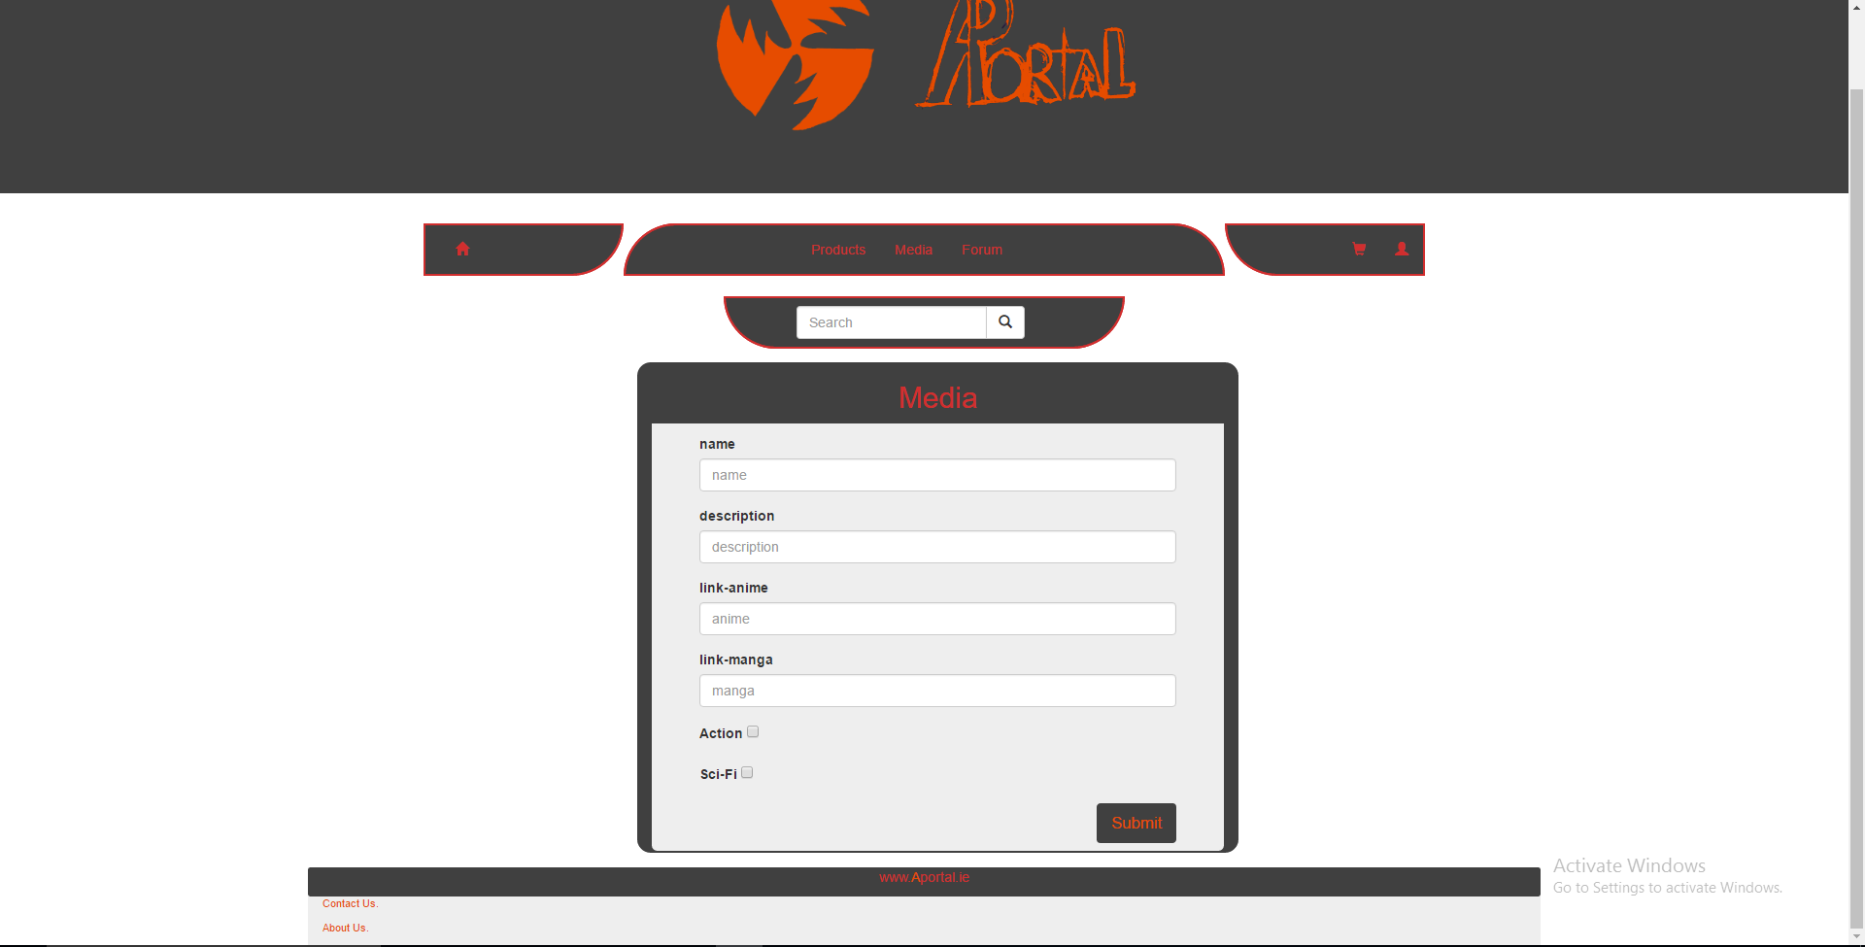

From the admin add media page admins will be able to add new media to the website ,as mentioned before in the add Product section this will be accessed through the edit media page for media it will be used for updates&addition of media & the image input field will go either up the top of the page just above the name input field or below the manga link input field just above the checkboxes.

Page : member Edit

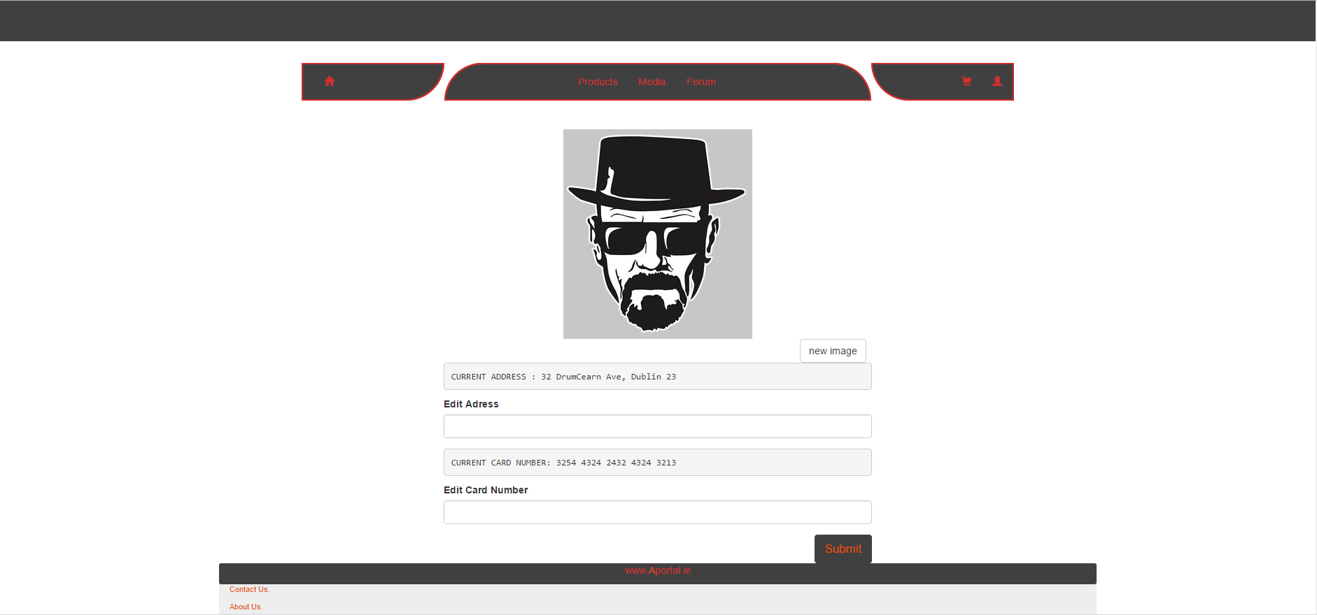

From the Member edit page members will be allowed to edit their profile photo, their home address for orders & there credit card number

once finished they press submit and those details will be Saved & Updated.

Note : Only members will be able to access this page.

Page : Product

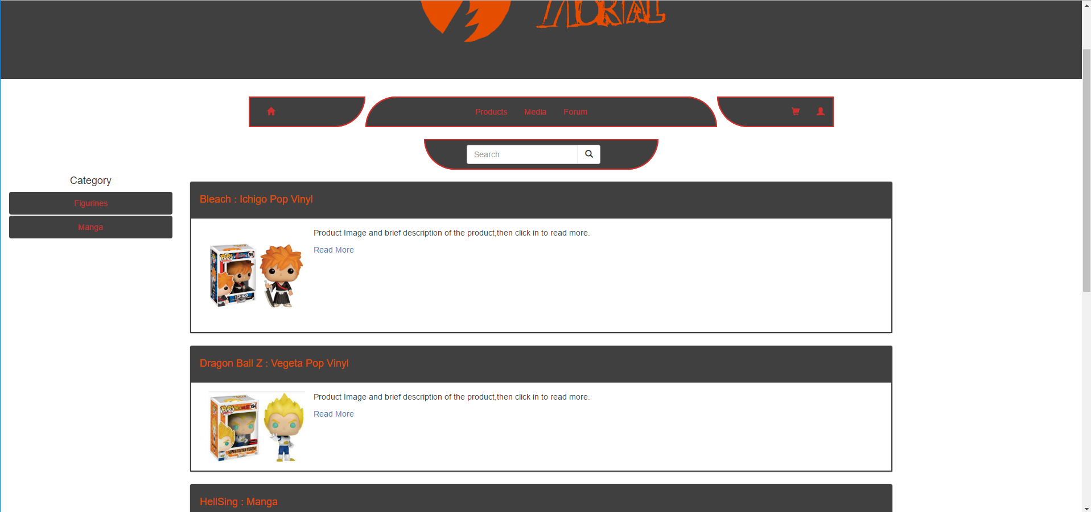

From products page users will be able to search for the websites products through the search bar & the navigation bar added to the left hand side of the page to accommodate product category similar to the admin support views left side navigation bar.

Page :moreProductInfo

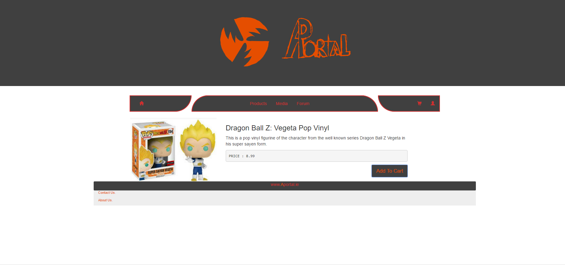

From this page users will be able to get more details on the product they have clicked read more into and they will also be able to click the add to cart button to add the product to their cart.

Note : Only members will be able to add items to cart and they must be signed in to do so.

Page : More Media Info

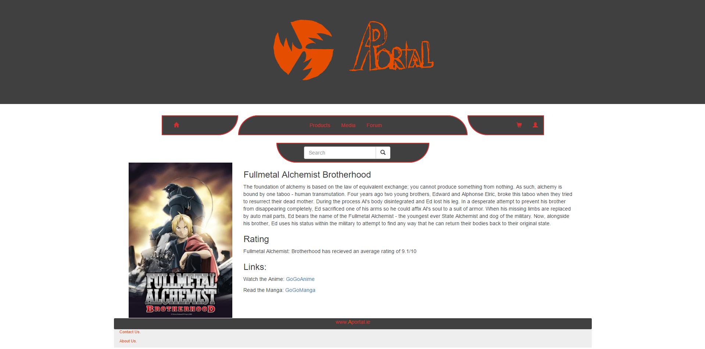

This is a screenshot of the more information page of a Series. On this page you can read a small description of the series, an average rating of the series and links to where you can watch the Anime or read the Manga.

Page : Media

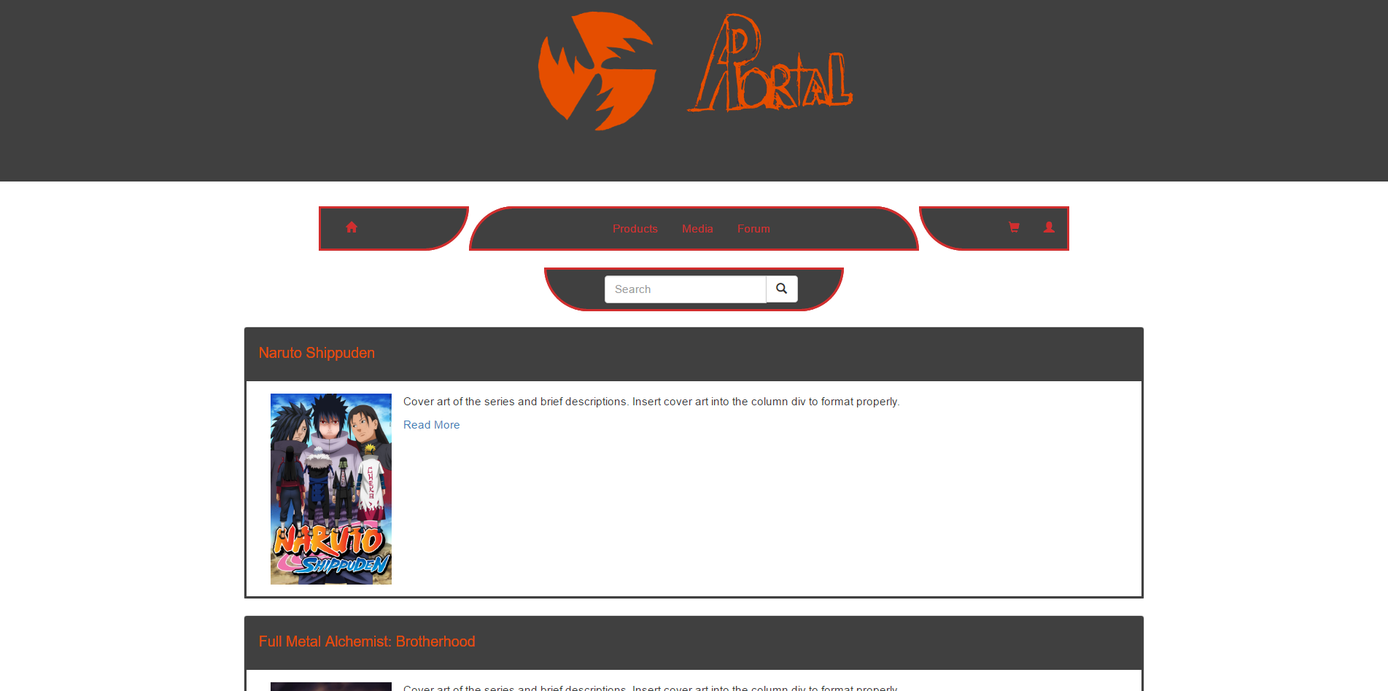

This is a screenshot of the overall series or media page. On this page you can scroll through a list of series where you can pick and choose which you would like to like to watch or read. To view more information on any series simply click on the read more link.

Page : Forum

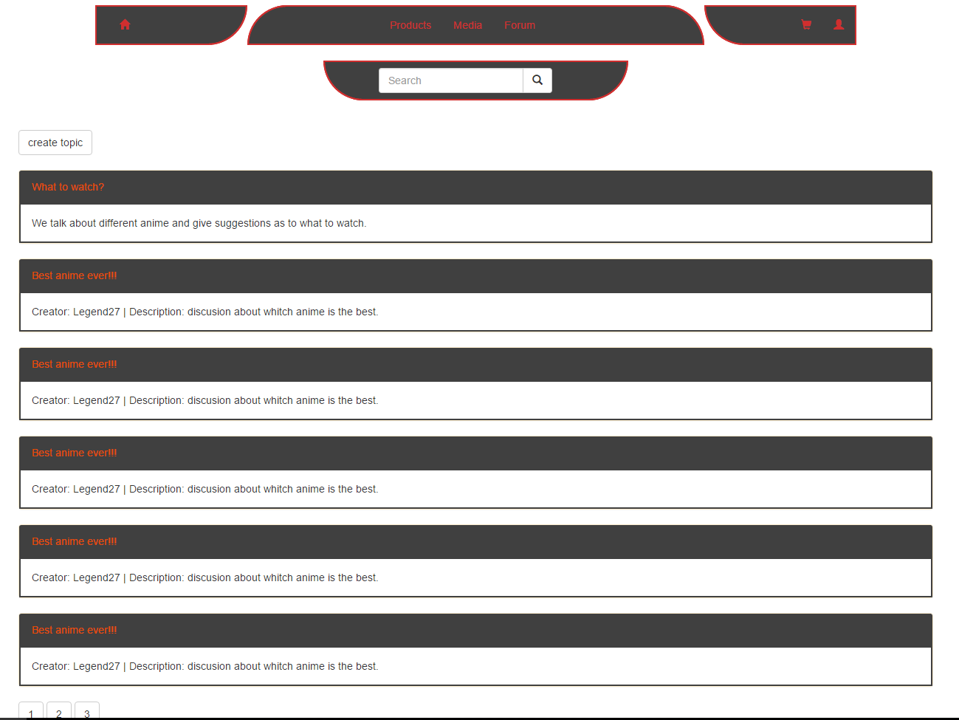

On this page the user will be able to view topics available ( only logged in user can go click on the topic and comment there), and create their own topics ( only logged in users can create topics ). Users can also search for topics.

Page : Comments

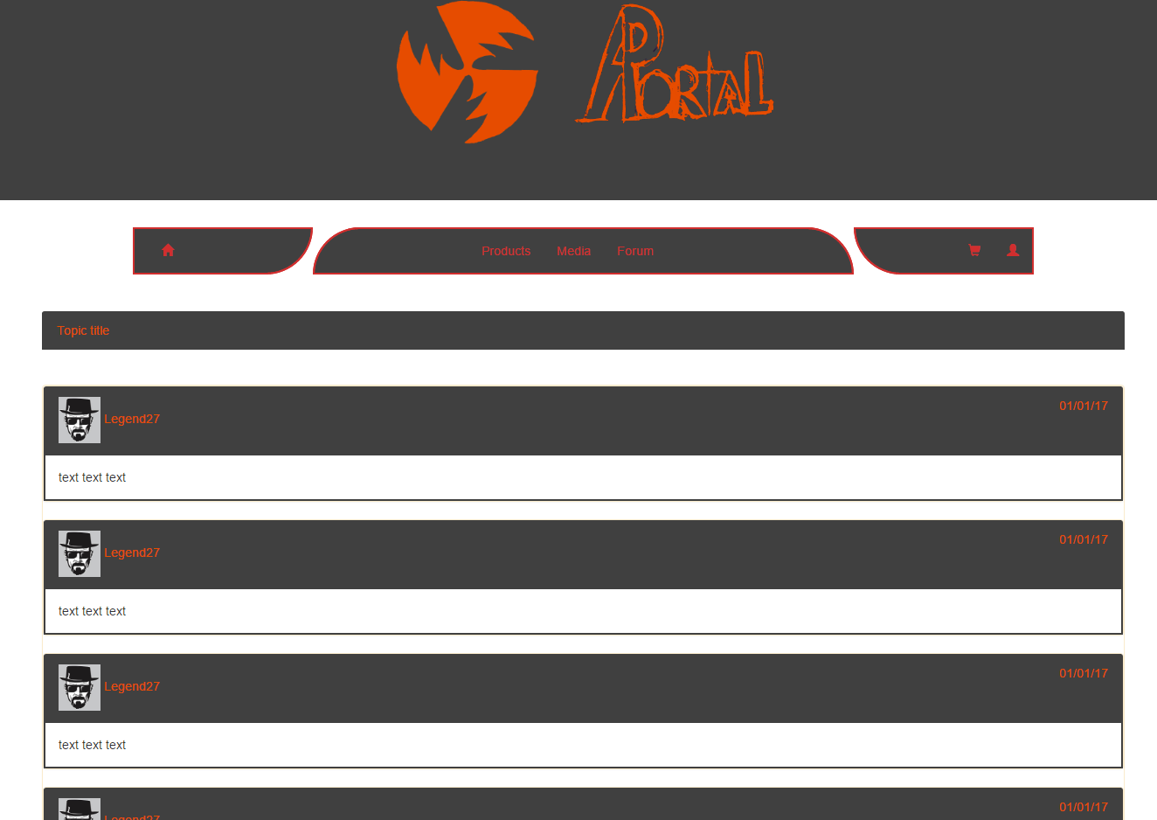

When the user clicks on the topic, he is sent to comments page for that topic. There the user is allowed to read comments and add his own .

Page : Cart

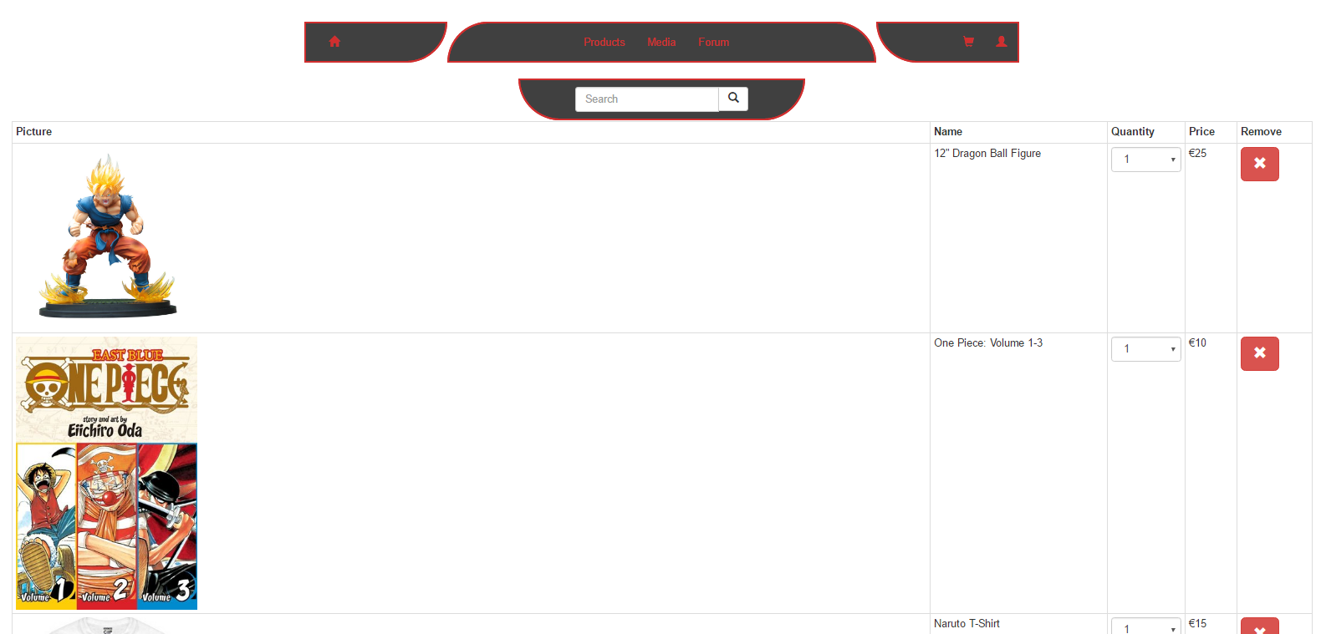

The user can add products to the cart and they appear here, the quantity dropdown allows them to choose the amount they want to buy, they can remove the item from their cart with the remove button, their total cost is at the bottom of the the page along with checkout allowing them to make their purchase.

Page : AboutUs

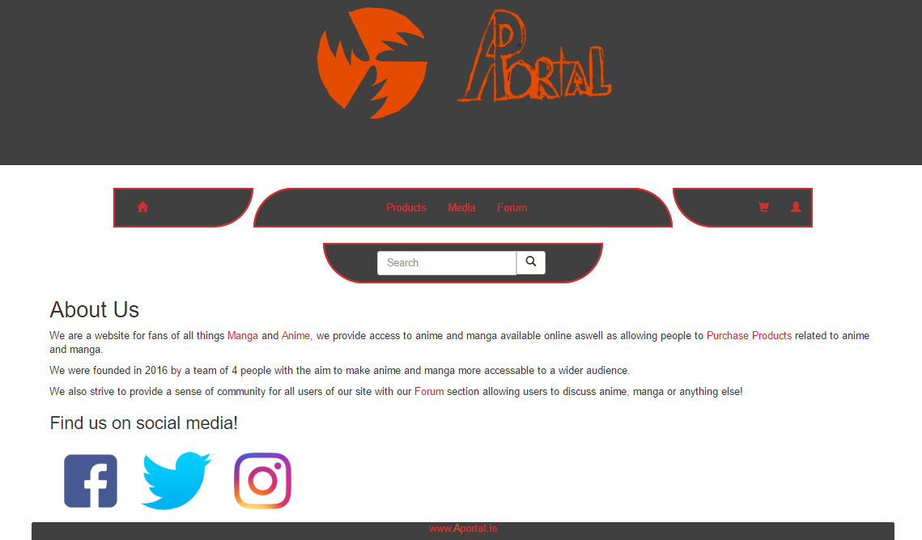

The user can view information about us, and can use the social media links to reach our facebook, twitter or instagram.

**ERD**

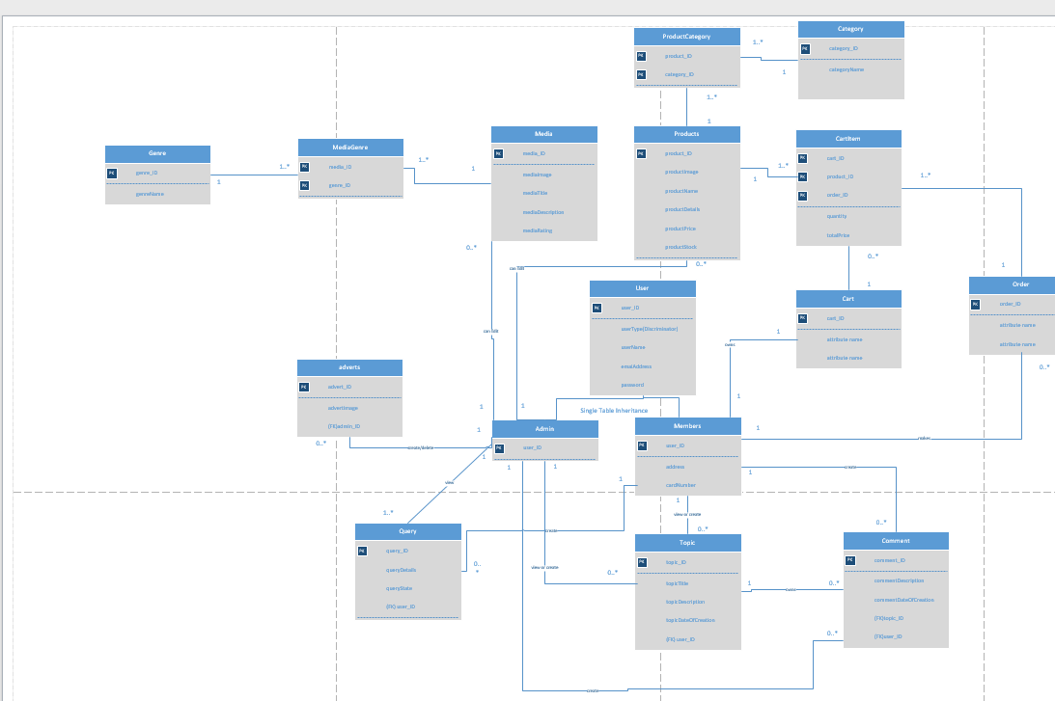

# 

# WebSite-PseudoCode

Pseudo-code for Media page.

|  |  |
| --- | --- |
| Page Title: | Media Page |
| Variables: | searchQuery = String, searchButtonPressed = boolean, pageNumberButton = 1: int, seriesID = int, maxSeriesID = int, user : generic user, noMatchCount = int |
| Pseudo-code: | IF (searchButtonPressed EQUALS false AND pageNumberButton EQUALS 1) { |
|  | pull series with ID's 1 - 4 and place the relevant info in each of the panels |
|  | } ELSE IF (searchButtonPressed EQUALS false AND pageNumberButton EQUALS 2) { |
|  | pull series with ID's 5 - 8 and place the relivant info in each of the pannels |
|  | } ELSE IF (searchButtonPressed EQUALS false AND pageNumberButton EQUALS 3) { |
|  | pull series with ID's 9 - 12 and place the relivant info in each of the pannels |
|  | } ELSE IF (searchButtonPressed EQUALS true AND searchQuery is populated) { |
|  | check if each series has appropriate data based on the searchQuery |
|  | FOR (seriesID = 1, until seriesID EQUALS maxSeriesID LOOP, increment seriesID by 1 each itteration) { |
|  | IF (series has appropriate data) { |
|  | pull the series ID('s) and display one series per pannel |
|  | } ELSE { |
|  | noMatchCount = noMatchCount + 1 |
|  | IF (noMatchCount == maxSeriesID) { |
|  | OUTPUT to screen "No matches to search please try again." |
|  | } END IF |
|  | } END ELSE IF |
|  | } END FOR LOOP |
|  | } END ELSE IF |

Pseudo-code for Products page.

|  |  |
| --- | --- |
| Page Title: | Products Page |
| Variables: | searchQuery = String, searchButtonPressed = boolean, pageNumberButton = 1: int, productID = int, maxProductID = int, user : generic user, noMatchCount = int |
| Pseudo-code: | IF (searchButtonPressed EQUALS false AND pageNumberButton EQUALS 1) { |
|  | pull products with ID's 1 - 4 and place the relevant info in each of the panels |
|  | } ELSE IF (searchButtonPressed EQUALS false AND pageNumberButton EQUALS 2) { |
|  | pull products with ID's 5 - 8 and place the relivant info in each of the pannels |
|  | } ELSE IF (searchButtonPressed EQUALS false AND pageNumberButton EQUALS 3) { |
|  | pull products with ID's 9 - 12 and place the relivant info in each of the pannels |
|  | } ELSE IF (searchButtonPressed EQUALS true AND searchQuery is populated) { |
|  | check if any products have appropriate data based on the searchQuery |
|  | FOR (productID = 1, until productID EQUALS maxProductID LOOP, increment productID by 1 each itteration) { |
|  | IF (product has appropriate data) { |
|  | pull the product ID('s) and display one product per pannel |
|  | } ELSE { |
|  | noMatchCount = noMatchCount + 1 |
|  | IF (noMatchCount == maxProductID) { |
|  | OUTPUT to screen "No matches to search please try again." |
|  | } END IF |
|  | } END ELSE IF |
|  | } END FOR LOOP |
|  | } END IF |

Pseudo-code for Cart page.

|  |  |
| --- | --- |
| Page Title: | Cart Page |
| Variables: | userSignInToken = boolean, cartSlotID = int, maxItems = int: 5, itemNum = int, maxCartSlotID = int |
| Pseudo-code: | IF (userSignInToken EQUALS false) { |
|  | Redirect user to sign in page |
|  | } ELSE IF (userSignInToken EQUALS true) { |
|  | User proceeds to Cart page |
|  | } END IF |
|  | FOR (cartSlotID = 1, until cartSlotID EQUALS maxCartSlotID LOOP, increment cartSlotID by 1) { |
|  | IF (itemNum > maxItems) { |
|  | itemNum set back to 5 |
|  | OUTPUT in pop-up “You may only have a max of 5 of any type of item in a transaction” |
|  | } ELSE { |
|  | Proceed with transaction |
|  | } END IF |

Pseudo-code for Sign In and Sign Up page.

|  |  |
| --- | --- |
| Page Title: | Sign In and Sign Up Page |
| Variables: | storedUsernames = String, enteredUsername = String, storedPassword = String, enteredPassword = String, storedEmails = String, enteredEmail = String |
| Pseudo-code: | IF (enteredUsername EQUALS storedUsernames AND enteredPassword EQUALS enteredPassword) { |
| Sign In | Sign the user in |
|  | } ELSE IF (enteredUsername NOT EQUALS storedUsername OR enteredPassword NOT EQUALS storedPassword) { |
|  | DO NOT sign in user and OUTPUT “Warning username or password incorrect, try again” |
|  | } END IF |
|  |  |
| Sign Up | IF (enteredUsername EQUALS storedUsername) { |
|  | OUTPUT “This username is already taken please try another” |
|  | } ELSE IF (enteredEmail EQUALS storedEmail) { |
|  | OUTPUT “This email is already tied to another account please try again” |
|  | } ELSE IF (enteredUsername NOT EQUALS storedUsername AND enteredEmail NOT EQUALS storedEmail) { |
|  | Store all information submitted and create account based on username and password |
|  | } END IF |
|  |  |
|  |  |
|  |  |
|  |  |
|  |  |
|  |  |

Pseudo-code for Forum page.

|  |  |
| --- | --- |
| Page Title: | Forum Page |
| Variables: | userSignInToken = boolean, topicID = int, lastTopicID = int, searchQuery = String, searchButtonPressed = boolean, noMatchCount = int |
| Pseudo-code: | IF (userSignInToken EQUALS false) { |
|  | Redirect user to sign in page |
|  | } ELSE IF (userSignInToken EQUALS true) { |
|  | User proceeds to Chat page |
|  | } END IF |
|  | IF (searchButtonPressed EQUALS true AND searchQuery is populated) { |
|  | check if any topics have appropriate data based on the searchQuery |
|  | FOR (topicID = 1, until topicID EQUALS lastTopicID LOOP, increment topicID by 1 each itteration) { |
|  | IF (topic has appropriate data) { |
|  | pull the topic ID('s) and display one topic per pannel |
|  | } ELSE { |
|  | noMatchCount = noMatchCount + 1 |
|  | IF (noMatchCount == lastTopicID) { |
|  | OUTPUT to screen "No matches to search please try again." |
|  | } END IF |
|  | } END ELSE IF |
|  | } END FOR LOOP |
|  |  |

Pseudo-code for More Product Info page.

|  |  |
| --- | --- |
| Page Title: | More Product Info Page |
| Variables: | userSignInToken = boolean, maxItems = int: 5, itemNum = int |
| Pseudo-code: | IF (userSignInToken EQUALS false) { |
|  | Redirect user to sign in page |
|  | } ELSE IF (userSignInToken EQUALS true) { |
|  | User proceeds to More Product Info page |
|  | } END IF |
|  |  |
|  | IF (itemNum > maxItems) { |
|  | itemNum set back to 5 |
|  | OUTPUT in pop-up “You may only have a max of 5 of any type of item in a transaction” |
|  | } ELSE { |
|  | Proceed with transaction |
|  | } END IF |

# 

# 

# 

# 

# WebSite - TESTCASE Matrix

|  |  |  |  |  |  |
| --- | --- | --- | --- | --- | --- |
| **Test Case Matrix** | | | | | |
| **TestCase No** | **Test Case Name** | **Input** | **Expected Outcome** | **Actual Outcome** | **Result (Pass/Fail)** |
| 1 | addProduct | Name, description, category, price, stock,date, productID | Product added |  |  |
| 2 | editProduct | Name, description, category, price, stock,date, productID | Product edited |  |  |
| 3 | deleteProduct | Remove | Product removed |  |  |
| 4 | addMedia | Name, description, genre,Links,image,date,animeID | Media added |  |  |
| 5 | editMedia | Name, description, genre,Links,image,date,  animeID | Media edited |  |  |
| 6 | deleteMedia | remove | Media removed |  |  |
| 7 | createTopic | Name, description, date, userID | Topic created |  |  |
| 8 | deleteTopic | remove | Topic removed |  |  |
| 9 | comment | Text , userID, date | Comment created |  |  |
| 10 | deleteComment | remove | Comment removed |  |  |
| 11 | sendQuery | userID, text, type, date | Query sent |  |  |
| 12 | View query | queries | Queries displayed |  |  |
| 13 | changeStateQuery | queries | State changed |  |  |
| 14 | createUser | userName, userID, password, email, address, card details | User created |  |  |
| 15 | Sign in | Name, password | Logged in |  |  |
| 16 | addToCart | ProductID, quantity, cartID | Product sent to cart |  |  |
| 17 | removeFromCart | ProductID, cartID | Product removed from cart |  |  |
| 18 | ConfirmOrder | ProductID, quantity, userID | Oreder confirmed |  |  |
| 19 | editAccount | userID, userName, email,password , card details, address, image. | account edited |  |  |

# 

# 

# WORKLOAD - Section 2

## CHRIS

### Page Design

Media page , more media information page

### & PseudoCode.

## RYAN :

### Page Design

Main,Support,admin Support,SignUpSignIn,more Product Info,product page html not css,adminHome.

### & ERD.

## IGORS :

### Page Design

index page ,admin Add Products page,admin AddMedia page, Forum page , Comments page.

### & TestCase Matrix.

## ARAN :

### Page Design

Cart page, about us page,memberEdit and populating of data on pages